Instant Care Family: Caregiver Guide

Use AxisCare Mobile to clock in and out, check your schedule, enter visit details, find directions to your client’s home and much more!


Downloading the App
1) Open the App Store (iPhone) or Play Store (Android).
2) Search for ‘AxisCare’. The logo looks like the image to the right.
3) Download the app (there is no charge).

Logging In
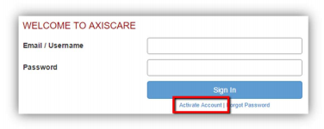
1) Activate your account (if you haven’t already) in order to log in. Here are step-by-step instructions on how to active your account:
- Go to your agency’s log in screen using your browser (9533.axiscare.com).
- Click on the ‘Active Account’ link just below the Sign In button.
- Enter the email address associated with your AxisCare profile (Contact Instant Care if you are unsure of this information).
- You will be sent an email to the email address entered. Either follow the link in the email or enter the activation code into AxisCare (you may also be asked for your date of birth and zip code). ***You have 20 minutes to complete this once the code is sent***
- Set your password.

2) Once you have activated your account you will need to open the AxisCare app and enter the following information:
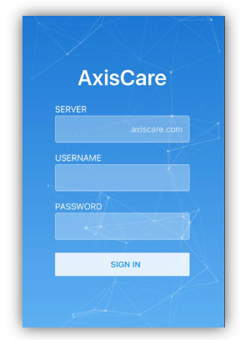
- Server: Enter Instant Care’s Server #: “9533”
- Username: firstnamelastname (Example: “johndoe”)
- Password: Enter the password you created during your interview or intake when activating your account.



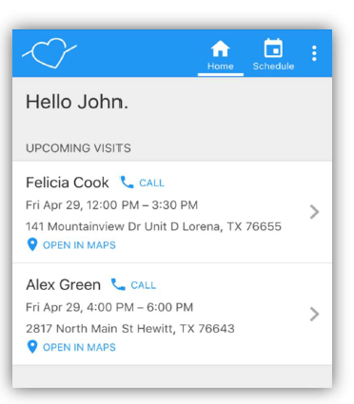
Home Screen
1) The Home Screen shows current visits that are in session as well as upcoming visits
2) Each visit shown includes the following details:
- Date and Time of Visit
- Clock In/Out Time
- Client’s address and ‘Open In Maps’ link to open address in Google Maps
- A ‘Start Travel Time for This Visit’ option may also be shown. Start this timer when you leave for your next visit to calculate inter-visit travel time.
- A ‘Call’ option may also be shown beside the client’s name which you may use to reach out to the client.

Entering Visit Information

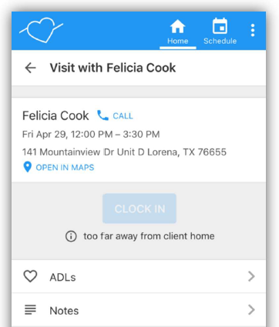
1) Click on visits to clock in and out, complete ADLs, notes, and expenses (Bonuses).
- Clocking In/Out: Click on the clock in/out button when you are ready to clock in/out for your shift.
- Your agency has set call windows that will restrict you to clocking in/out within a certain time frame of the visit time You will not be able to clock in/out of your shift if you are outside of that window.
- Your agency may also set up a geo-fence that will only allow you to clock in/out once you are in a specific vicinity of the client’s home. If you are outside of the geo-fence you will not be able clock in/out.
- Clock in/out button can only be clicked on once. Clock in/out time cannot be changed once recorded.
- ADLs: Check all activities that have been completed for your shift and save.
- Notes: Enter notes regarding the shift chosen and save.
- Expenses: Enter total expenses for the chosen visit. (This will only be for staffing bonuses previously discussed with the coordinator, THEY WILL BE AUDITED).
- SEE SCREENSHOTS BELOW
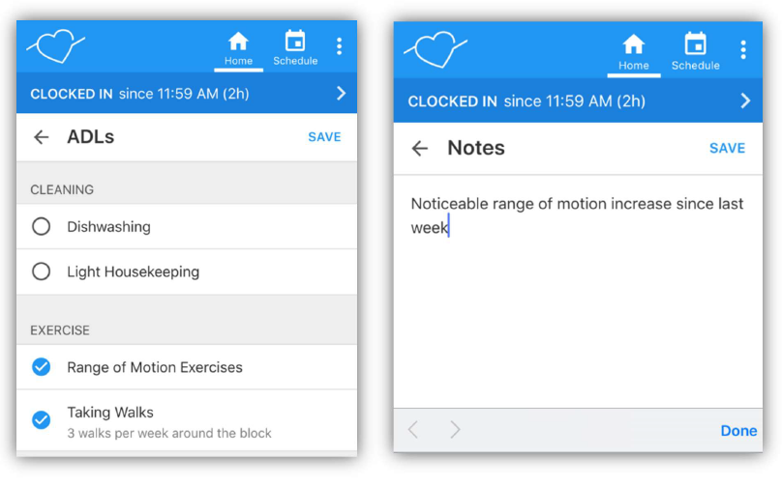
Schedule Tab
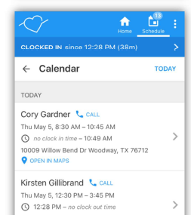
1) Calendar: The calendar will show you the visits you are assigned to for the next week.
- Click on the visit to see visit details and to record ADLs, notes, and expenses (bonuses).

Menu (Three dots at top right of your screen)

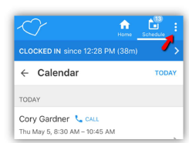
- Refresh: Click here to refresh your screen to see the most recent changes.
- Sign Out: Click here to log out of your account.
- About: For Office Use

Thanks for being a part of the Instant Care Team! If you have any questions or concerns please do not hesitate to reach out to our staff at 602-993-0297



